1. 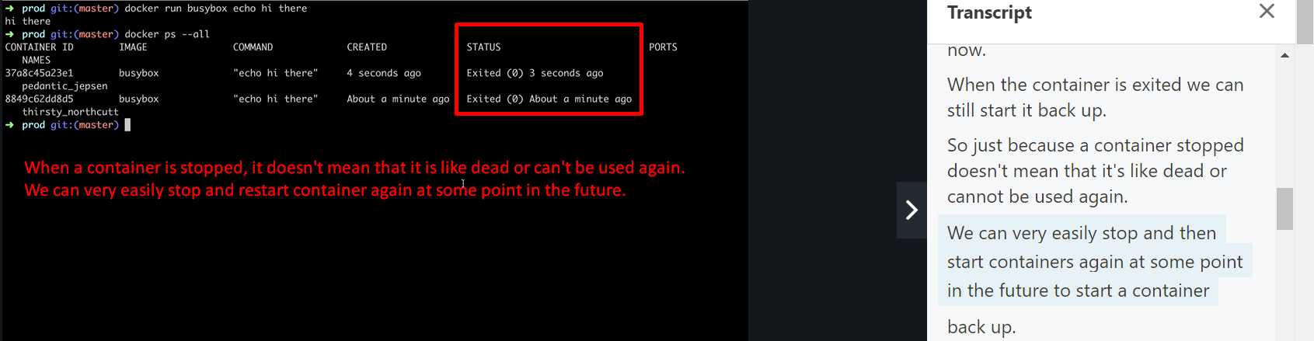
2. 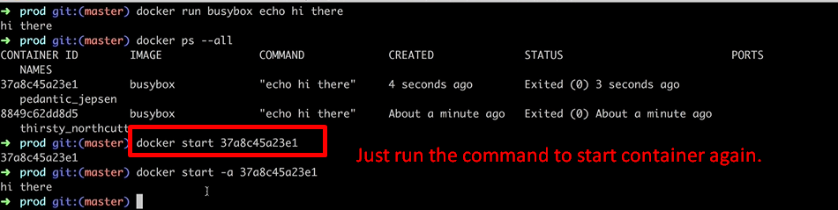
3. 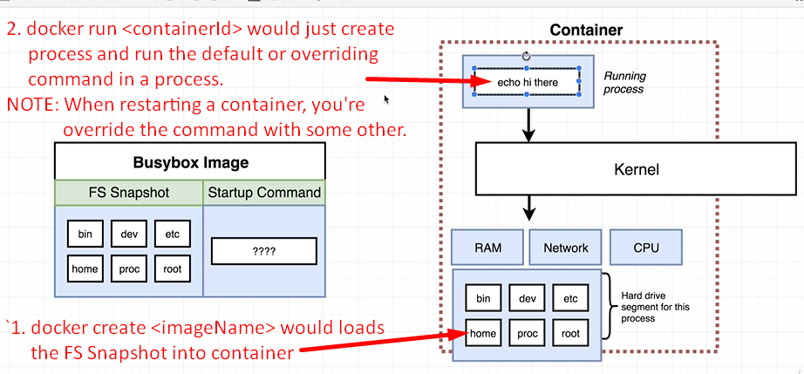
4. Having a solid understanding of lifecycle of container is very useful in troubleshooting or debugging a running container.